
The difference between Li Bai and Du Fu's Poems
Introduction to Probability and Statistics (1004)


1930026115 TANG Zhongyi 唐仲一
conduct a hypothesis testing about poetry's length based on two samples of poetry
1930026017 CHEN Ziqi 陈子淇
Statistics and write results and discussions
1930026111 QIN Yuao 覃逾鳌
write the material and method、conclusion about the report
1930026061 KONG Deran 孔德然
write the abstract,title and introduction, put the pieces together.
1930026174 ZHENG Yuhan 郑宇涵
processed the original data, writing programs to statistics the word frequency, and offered these data
1930026143 XUE Shaojie 薛劭杰
Chi-square test to compare the image distribution of poetry

Group 6

Content
1.Abstract 1
2.Introduction 1
3.Materials and Methods: 2
3.1 Comparative experiment of poem length: 2
Judgement standard: 2
Method: 2
Program code to calculate the average word count and variance: 3
3.2 Are the distribution of li bai' s and du fu' s poetry images the same in three hundred poems of tang dynasty? 3
Data involved: 3
Method: 3
Program code for word frequency statistics: 4
4.Results: 4
5.Discussion 8
6.Conclusion: 10
Two-sample hypothesis test: 10
Chi-square goodness of fit test: 10
Value: 11
7. References 12

1.Abstract
Chinese traditional culture is broad and profound, especially poetry culture. It uses simple rhyming sentences to describe countless scenes, moods, ideals and other things the poet wants to express, which lets people yearn. As a great poet, Li Bai and Du Fu represent the flourishing age of poetry in Tang Dynasty. So our group want to explore the differences in their poems. The members found that the images and length of the two poems are almost the same in "Three Hundred Tang Poems".
Having a discussion, calculation and investigation on this subject firstly is to let people see the charm of poetry and the significance of traditional culture. Second, let people see the wonderful use of statistics. It can not only be used in science, but also in literature. Statistics can be used flexibly in many things around people.

2.Introduction
The project is to explore the differences between Li Bai's and Du Fu's Poems in "Three Hundred Tang Poems". People all know that the poetry culture has a long history, and the Tang Dynasty is the prosperous era of poetry rising. Here, poetry is popular and widely spread, and countless famous great poets have come out. Li Bai and Du Fu are the two bright pearls among the stars of the Tang poetry circle, attracting countless future generations to explore. On this basis, our group want to make full use of the statistical knowledge we have learned in this semester to study literature and poetry, and prove that statistics is useful in many aspects. It is not only a science discipline, but also has practical significance and use.
Our group applied descriptive statistics and statistical inference to complete our research. The students choose to study the differences between Li Bai's and Du Fu's poems in three hundred Tang poems. In order to verify the length difference between poems, the students choose the t test of hypothesis test. Hypothesis test, also known as statistical hypothesis test, is a statistical inference method used to determine whether the differences between samples and samples, between samples and population are caused by sampling errors or essential differences. The method of goodness of fit test is used to judge image. Goodness of fit test is one of the important contents of statistical significance test with chi square statistics. It calculates the expected frequency of each category in the classification variable according to the overall distribution, compares it with the observation frequency of the distribution, and judges whether there is significant difference between the expected frequency and the observation frequency, so as to achieve the purpose of analyzing from the classification variable. These scientific statistical methods make the results more reliable and convincing.

3.Materials and Methods:
The materials used are mainly from《 three hundred poems of tang dynasty》.

3.1 Comparative experiment of poem length:

Judgement standard:
In the experiment of comparing the length of poems by li bai and du fu, the criterion of judging the length is the number of words in the poems by li bai and du fu.

Method:
Li bai's 30 poems and du fu's 30 poems were selected as samples from the 300 poems in the tang dynasty. After recording and calculating the average number of words and the variance of the number of words in 30 poems by li bai and du fu, the double-sample hypothesis test method was used for data processing. Under the condition of significance level α= 0.05, li bai's poems and du fu's poems were tested
 | (Libai)length of poem | (Dufu)length of poem
average number
variance
Figure 1

Program code to calculate the average word count and variance:
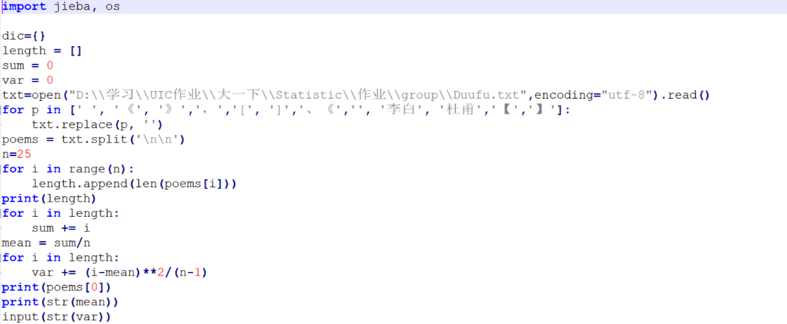
Figure 2

3.2 Are the distribution of li bai' s and du fu' s poetry images the same in three hundred poems of tang dynasty?

Data involved:
Li bai' s 25 poems were all selected from 300 poems of tang dynasty.
All of du fu' s poems in three hundred tang poems.

Method:

In the comparative study of poetic images, the chi-square test method is adopted to take du fu's all poetic images as a whole and li bai's 25 poetic images as samples.In this process, it is mainly python's "word frequency statistics program" to help process the image frequency data.The more frequent images are divided into five categories: pride and ambition, sadness and melancholy, nobility and loyalty, separation and pain, grace and leisure.

Secondly, the frequency of images in du fu's poems is taken as a whole, and that in li bai's poems is taken as a sample. Chi-square test method is used to calculate the frequency under the premise of α= 0.05.、

Program code for word frequency statistics:
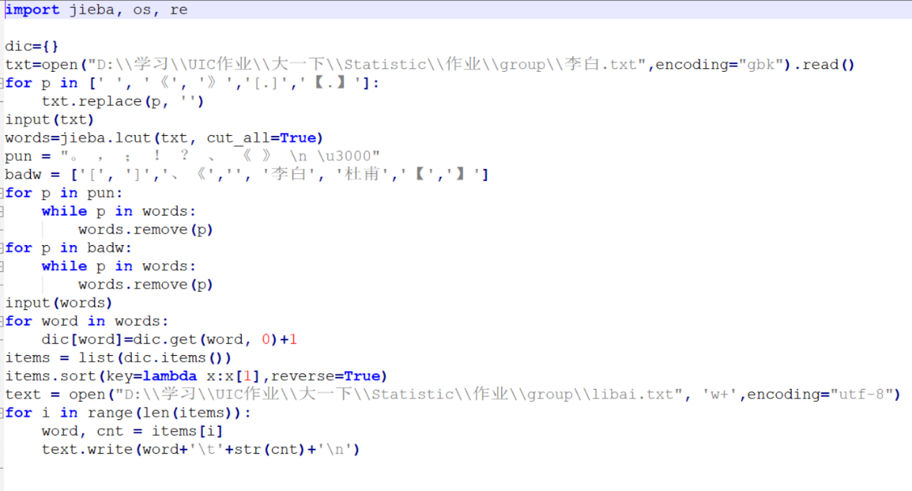
Figure 3

4.Results:
In order to make inference statistics, Our team members used Hypothesis testing about two Population to study the difference between the lengths of Libai ’s poems and Dufu ’s poems in “Three Hundred Tang Poems” and Chi-square test. The distribution of image content in Dufu's poems.

The first is to use Hypothesis testing about two Population to study the difference between the three hundred poems of Libai and Dufu.
Hypothesis testing about two Population

In order to find out whether Libai(μ1)’s poems are longer than Dufu’s(μ2) poem in length, at a significance level of α = 0.05, we are going to conduct a hypothesis testing based on two population.

We set $H_{0}$: Libai’s poems don’t differ from Dufu’s poems in length. That is μ1=μ2.
Versus $H_{a}$: Libai’s poems differ from Dufu’s poems in length. That is μ1≠μ2.

According to the statistical data obtained by our statistical calculation,, we known that

$\overline{x}1=115.32$ n1 = 30 s1 = 10109.47
$\overline{x}2=164.64$ n2 = 30 s2 = 47281.82

Since s1>3*s2, our group members use an unequal variances procedure.
Therefore, $v= \frac{(\frac{s1^{2}}{n1}+\frac{s2^{2}}{n2})^2}{\frac{{\left(\frac{s1^{2}}{n1}\right)}^{2}}{n1-1}+\frac{{\left(\frac{s2^{2}}{n1}\right)}^{2}}{n2-1}}$,
df = the integer portion of v, so df = 26
So, t α/2 = 2.056, then our group members calculate the test statistic.
$$t=\frac{\left(\overline{x}1-\overline{x}2\right)-D0}{\sqrt{\frac{s1^2}{n1}+\frac{s2^2}{n2}}}$$
Then we get t = -0.0051> -t α/2

So, our group members do not reject $H_{0}$ in favor of $H_{a}$ at a significance level of 0.05. That is, our group members don’t have sufficient evidence to say that Libai’s poems differ from Dufu’s poems in length.
The second is to use Chi-square test to compare Li Bai's poem and Du Fu's poem in "Three Hundred Tang Poems" to study whether the distribution of image content in the two poets' poems is the same.
Chi-square Goodness of Fit Test

At the 0.05 significance level, can our group members conclude that the image content distribution of Libai is different from Dufu in "Three Hundred Tang Poems"?

$H_{0}$: The image distribution is the same of both poets.
$H_{a}$: The distributions are different.

Our group members select 25 samples poems of Libai from "Three Hundred Tang Poems":

 | Proud & Ambitious | Sad & Melancholy | Noble & Loyalty | Parting Pain | Elegant & leisurely
Libai | 46 | 29 | 13 | 21 | 33
Figure 4
Total = 46 + 29 + 13 +21 + 33 = 142

And our group members select all Dufu’s poem from "Three Hundred Tang Poems":

Figure 5

Our group members get the image content proportion distribution of Dufu.
Dufu:
Proud & Ambitious = 142 * 30% = 42.6
Sad & Melancholy = 142 * 29% = 41.18
Noble & Loyalty = 142 * 10% = 14.2
Parting Pain = 142 * 11% = 15.62
Elegant & leisurely = 142 * 20% = 28.4

 | Proud & Ambitious | Sad & Melancholy | Noble & Loyalty | Parting Pain | Elegant & leisurely
Libai | 46 | 29 | 13 | 21 | 33
Dufu | 42.6 | 41.18 | 14.2 | 15.62 | 28.4
Figure 6
$x^{2}=\sum_{i=0}^{k}{\frac{{\left(fi-Ei\right)}^{2}}{Ei}}$ = $\frac{{\left(46-42.6\right)}^{2}}{42.6}+ \frac{{\left(29-41.18\right)}^{2}}{41.18}+$……+ $\frac{{\left(33-28.4\right)}^{2}}{28.4}$
≈ 0.2714 + 3.5491 + 0.1014 + 1.8530 + 0.7451
= 6.52

Therefore, according to the Chi-square table,
α = 0.05, df = k–1 = 5–1 = 4, critical value ${x^{2}}_{0.05}$ = 9.48773.

In conclusion, $x^{2}$ = 6.52 < 9.48773, it cannot reject the null hypothesis, the sample shows no difference between the image content distribution of two poets.

5.Discussion
The goal of our project is to study the difference between the poems of Libai and Dufu in "Three Hundred Tang Poems", which are divided into two parts: the length and the image of the poem. The length and the image of the two poems are compared, and the difference is not big. Through the above two statistical methods: Hypothesis testing about two Population and Chi-square test, Our team members can get the result that Our team members do not have enough evidence to say that the length of Libai ’s poems and Dufu ’s poems are different and there is a difference between the distribution of the imagery of the two poets . The poets of the two poets have no difference in length and image.
Because when Our team members counted Libai's poems and Dufu's poems, our group found that Libai had a poem with a length of 1114. This value is an obvious outlier. The outliers in a batch of data are worth paying attention to. It is very dangerous to include the outliers in the calculation and analysis of the data without culling, which will have an adverse effect on the results. Paying attention to the occurrence of outliers and analyzing the causes of them often become an opportunity to find problems and improve decision-making. The box plot provides us with a standard for identifying outliers: outliers are defined as values ​​less than Q1-1.5IQR or greater than Q3 + 1.5IQR.
According to our further discussion and research. Our group use the "Descriptive Statistics: Numerical Methods" in Chapter 3 to draw "The Box-and-Whiskers Display" to show a set of data dispersion and determine outliers and their number. It is found from the picture that there are outliers in both poems. There are two outliers in Libai's poems, which are 369 and 361, and one out of Dufu's poem is 1114. The illustrations below are The Box-and-Whiskers Display of Libai's poems and Dufu's poems, respectively.
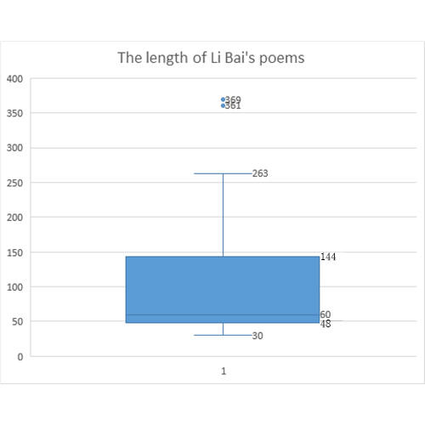
Figure 7
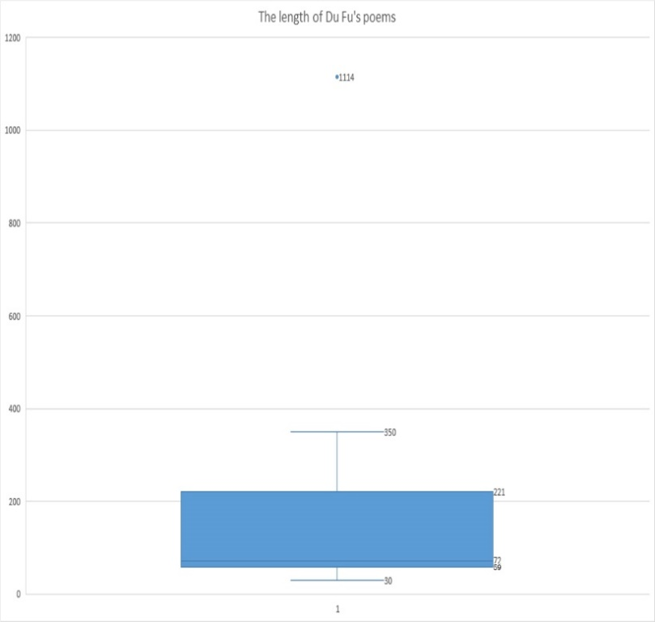
Figure 8

The box plot drawing depends on the actual data, there is no need to assume that the data follow a specific distribution form, and there are no restrictive requirements on the data. It is only a true and intuitive representation of the original appearance of the data shape; The standard of the value is based on the quartile and quartile range. The quartile has a certain resistance. Up to 25% of the data can become arbitrarily far without greatly disturbing the quartile, so Abnormal values ​​cannot influence this standard, and the results of identifying abnormal values ​​in the box plot are more objective. This shows that the box plot has certain advantages in identifying outliers.
Therefore, in the study of the length of Libai's poems and Dufu's poems, our group can first calculate the outliers in the two sets of data, and consider whether to remove the outliers for calculation. Consider removing the outliers and drawing The Box-and-Whiskers Display again, and there are still extreme values.

6.Conclusion:
In our exploration of the similarities and differences between the poems of li bai and du fu in the three hundred poems of tang dynasty. Mainly used two methods, two-sample hypothesis test and chi-square goodness of fit test.

Two-sample hypothesis test:
Double sample hypothesis test on the length of two great poet li bai and du fu's poetry played a key role on contrast, after collecting materials, numerical extraction, after calculation, statistics and a series of steps, getting the result: in the case of alpha = 0.05, there is not enough evidence to prove the started the first length of li bai and du fu's poems are different.

Chi-square goodness of fit test:
Chi-square test of goodness of fit is mainly in detecting image content distribution and li bai, du fu in the tang started for different use, after data collection, image classification, image extraction, word frequency statistics, calculation and a series of steps, in the case of alpha = 0.05, concluding that the two poets the conclusion of the image content distribution of no difference.

Value:
Du fu and li bai were both representative poets of the tang dynasty. They stood on two peaks of poetry in the tang dynasty, one was called realism, the other was called romanticism. Which of them is the wiser or the better can’t be said, because both of them are geniuses. To understand their differences in poetry, big data statistics are needed. This time, the writing habits of the two poets were statistically analyzed and calculated in terms of the length and image of the poems, so as to obtain the data of their "writing preference", so as to better understand the writing habits of the two poets and their era. Li bai represents the youth of the tang dynasty, while du fu represents the maturity of the tang dynasty. In Yu qiuyu's Chinese context, it is mentioned that students at Peking University ranked their favorite poets, among which li bai was the first and du fu was the second. In the eyes of most people, the length of poetry and the use of imagery are undoubtedly the two important factors affecting the choice, so this is the breakthrough of the two studies. Surprisingly, according to the calculated data, the two great poets were almost identical in both respects. This strongly suggests that the factors that influence people's preference for these two poets are not the length of the poems or the use of imagery, but other factors.

7. References
- Yu qiuyu, Chinese context, changjiang literature and art press, February 5, 2013.
- Three hundred poems by Li Bai Tang:
http://www.shicimingju.com/shicimark/tangshisanbaishou_1_1__0.html
- Three hundred poems by Du Fu Tang Dynasty:
http://www.shicimingju.com/shicimark/tangshisanbaishou_1_1__0.html

